函数：

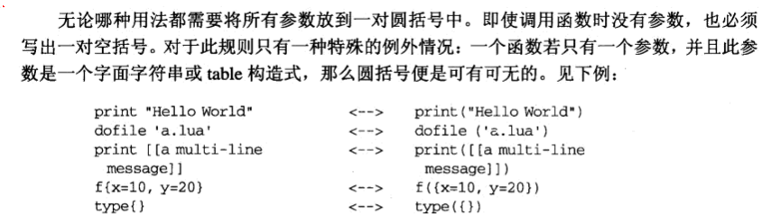

函数多重返回值:
function maximum(a)
local mi = 1 --最大的索引值
local m = a[mi] --最大值
for i, val in ipairs(a) do
if val > m then
mi = i
m = val
end
end
return m, mi
end
print(maximum({8, 10, 23, 12, 5})) // 输出 23, 3

function foo0() end
function foo1() return "a" end
function foo2() return "a", "b" end
print(foo0())
print(foo1())
print(foo2())
print(foo2(), 1)
print(foo2() .. "X")
function foo(i)
if i == 0 then return foo0()
elseif i == 1 then return foo1()
elseif i == 2 then return foo2()
end
end
print(foo(1))
print(foo(2))
print(foo(0))

--- unpack 返回数组所以的元素
print(unpack{10, 20, 30})
a,b = unpack{10, 20, 30}
print(a,b)

变长参数:
------- 变长参数 --------
function add(...)
local s = 0;
for i, v in ipairs{...} do
s = s + v
end
return s
end
print(add(3, 4, 10, 25, 12)) --> 54

--- select('#', ...) 返回所有变长参数的总数
for i = 1, select('#', ...) do
local arg = select(i, ...) --得到第i个参数
<循环体>
end

具名实参:
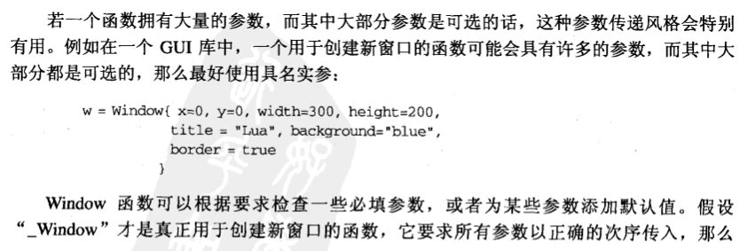
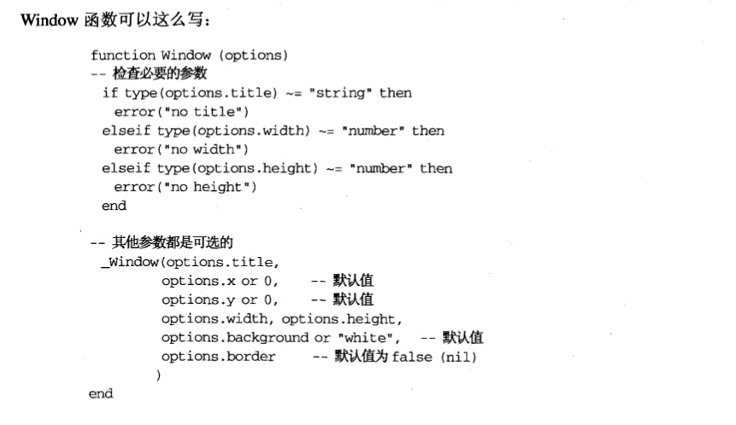

闭合函数:
--------- 闭合函数 --------
names = { "Peter", "Paul", "Mary" }
grades = { Mary = 10, Paul = 7, Peter = 8 }
function sortbygrade(names, grades)
table.sort(names, function(n1, n2)
return grades[n1] > grades[n2] -- 比较年级
end)
end

--c1、c2是建立在同一个函数上，但作用在同一个局部变量的不同实例上的两个不同的闭包。
--技术上来讲，闭包指值而不是指函数，函数仅仅是闭包的一个原型声明；
--尽管如此，在不会导致混淆的情况下我们继续使用术语函数代指闭包。
function newCounter()
local i = 0
return function() -- anonymous function
i = i + 1
return i
end
end
c1 = newCounter()
print(c1()) --> 1
print(c1()) --> 2
c2 = newCounter()
print(c2()) --> 1
print(c1()) --> 3
print(c2()) --> 2

-- 函数调用 sample01 --
function foo(...)
for i = 1, arg.n do
print("Foo:" .. arg[i])
end
end
foo("one", "two")

-- 函数调用 sample02 --
function goo(t)
for k,v in pairs(t) do
print(k .. "=" .. v)
end
end
goo({x=10, y=20})

function contact(t)
-- add the contact ‘t’, which is
-- stored as a table, to a database
for k,v in pairs(t) do
print(k .. "=" .. v)
end
end
--符号【【...】】是表示多行字符串的方法
contact {
name = "Game Developer",
email = "hack@ogdev.net",
url = "http://www.ogdev.net",
quote = [[
There are 10 types of people
who can understand binary.]]
}
contact {
-- some other contact
}

----- 生成一个随机 5 位数 --------
math.randomseed(os.time())
a = ""
for i=1, 5 do
b = math.random(0, 9)
a = a .. b
end
print(a)

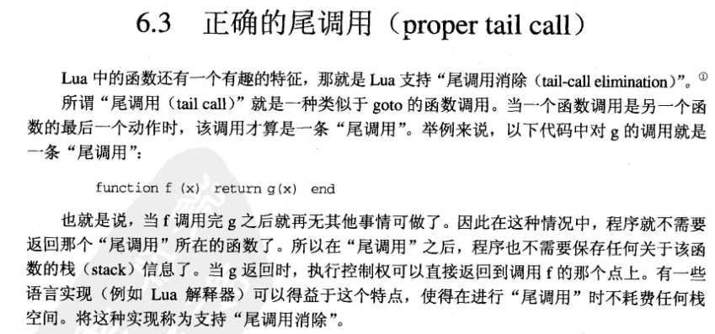
--------- 消除尾调用 ------
-- 迷宫游戏
function room1()
local move = io.read()
if move == "south" then return room3()
elseif move == "east" then return room2()
else print("invalid move")
return room1()
end
end

function room2()
local move = io.read()
if move == "south" then return room4()
elseif move == "west" then return room1()
else print("invalid move")
return room2()
end
end

function room3()
local move = io.read()
if move == "north" then return room1()
elseif move == "east" then return room4()
else print("invalid move")
return room3()
end
end

function room4()
print("congratulations!")
end

room1();

